Supplementary Information for

Animal heat activated cancer therapy by a traditional catalyst TiO2-Pd/graphene composites

Yanlong Yu1, Pengchong Jiang1, Yabin Yan1, Hanbo Li1, Lixin Zhang1, Shan Jiang2 Wensheng Yang2 & Yaan Cao1,*

1Key laboratory of Weak-Light Nonlinear Photonics, Ministry of Education, TEDA Applied Physics Institute and School of Physics, Nankai University, Tianjin 300457, China

2College of Chemistry, Jilin University, Changchun 130012, P.R. China



Fig. S1. XRD patterns of TiO2, TiO2-Pd, TiO2/graphene and TiO2-Pd/graphene. Inset is the enlarged XRD peaks of crystal plane (101).

Table S1. Cell parameters, cell volume and crystallite size of TiO2, Pd-TiO2 and GO/Pd-TiO2 samples, which were derived from XRD data given in Fig. S1.

|  |  |  |  |  |  |
| --- | --- | --- | --- | --- | --- |
| Sample | a=b (Å) | c (Å) | Cell volume (Å3) | Crystallite size(nm) | BET specific surface area(m2/g) |
| TiO2 | 3.789 | 9.509 | 136.5 | 12.6 | 63.1 |
| TiO2-Pd | 3.791 | 9.510 | 136.8 | 10.7 | 82.5 |
| TiO2/graphene | 3.790 | 9.507 | 136.6 | 10.5 | 84.6 |
| TiO2-Pd/graphene | 3.792 | 9.512 | 136.6 | 9.3 | 93.7 |

The diffraction peaks corresponding to crystal planes (101) and (200) in the XRD patterns were selected to determine the cell parameters and cell volumes of the samples using Scherrer’s formula.



Fig. S2. XRD patterns of TiO2, X%Pd-TiO2 and Y%graphene/Pd-TiO2.

 

Fig. S3. XPS spectra for TiO2 and TiO2-Pd/Graphene. (A) Cl2p, (B) C 1s.

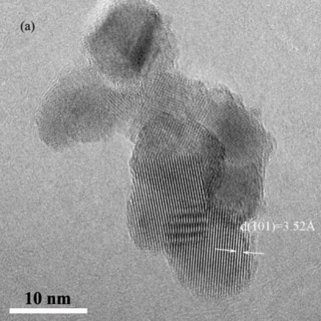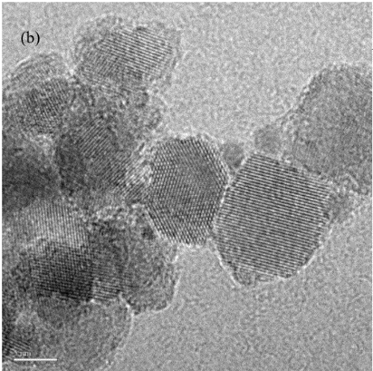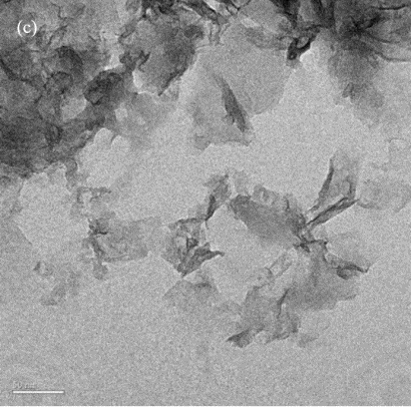

Fig. S4. TEM images of TiO2 (a), TiO2-Pd (b) and Graphene (c).



Fig. S5. FR-IR spectra of TiO2-Pd/Graphene



Fig. S6. Surviving fraction of A549 cancer cells as a function of concentration in the presence of all samples.

 



Fig. S7. Surviving fraction of synovial cells as a function of concentration for (A) TiO2-Pdx% for 4 h at 37oC; (B) TiO2-Pd/graphene x% for 4 h at 37oC; (C) TiO2-Pd/graphene at different temperatures for 16 h; (D) TiO2-Pd/graphene for different time.



Fig. S8. Surviving fraction of A549 and smooth muscle cells as a function of concentration of TiO2-Pd and TiO2-Pd/graphene.

C:\Users\dell-yabin\Documents\Tencent Files\307291511\FileRecv\0.jpg.tifC:\Users\dell-yabin\Documents\Tencent Files\307291511\FileRecv\tio2-1000027-xin.jpg.tif

C:\Users\dell-yabin\Documents\Tencent Files\307291511\FileRecv\pd-500032.jpg.tifC:\Users\dell-yabin\Documents\Tencent Files\307291511\FileRecv\pd-1000049.jpg.tif

C:\Users\dell-yabin\Documents\Tencent Files\307291511\FileRecv\40go-1000073.jpg.tif

Fig. S9 optical microscopy pictures of A549 cancer cells treated in the presence of (a)TiO2, (b)Graphene, (c)TiO2/graphene, (d)TiO2-Pd and (e)TiO2-Pd/graphene (100 μg/mL) for 16 hours at 37oC.

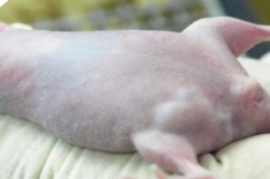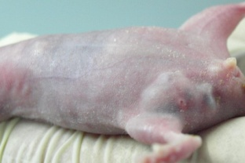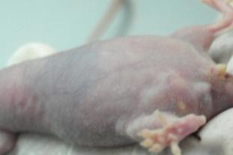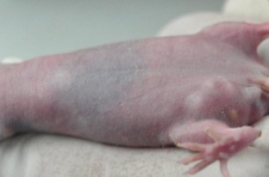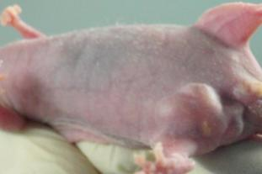

Fig. S10 Representative photos of tumors on mice injected with TiO2 after 0,2,4,5,9 days

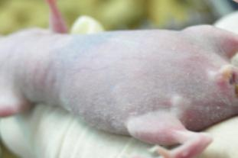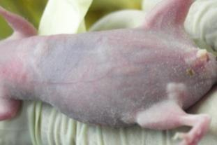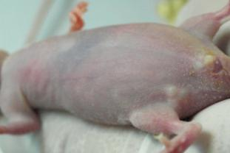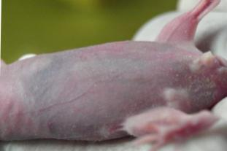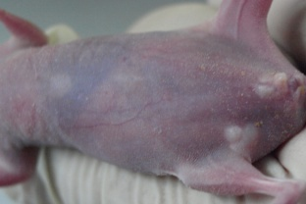

Fig. S11 Representative photos of tumors on mice injected with TiO2-Pd after 0,2,4,5,12 days

The calculation of the surface TiO2 structure were based on the density functional theory, as implemented in the VASP code. The ex-change-correlation energy was represented by the generalized-gradient approximation (GGA) of Perdew, Burke and Ernzerhof (PBE). An anatase TiO2 model of 48 atoms with an exposed (101) facet is created. The vacuum lamp is set at 20 Ai.

The valence electronic configurations for the O, Ti, Pd and Cl atoms were 2s22p4, 3s2 3p63d24s2, 4d10 and 3s23p5, respectively. The plane wave energy cutoffs were taken to be 520 eV and the k-point set is 2 ×2 × 2. Compared with the experimental results, the theoretical calculation usually results in an underestimated band gap, caused by the shortcoming of the exchange–correction functional in describing the excited states

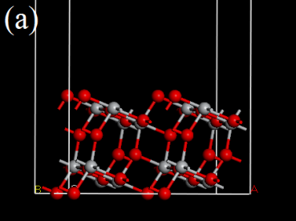

Fig. S12. Theoretical calculated band structure and density of states of pure TiO2.

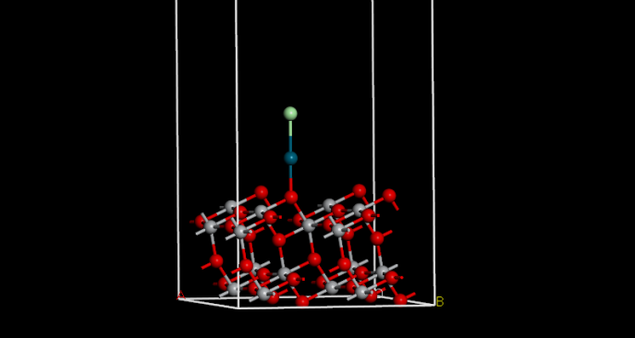

Fig. S13. Theoretical calculated band structure of TiO2-Pd (O-Pd-Cl)

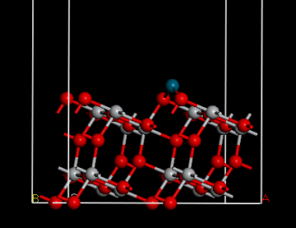

Fig. S14. Theoretical calculated band structure of TiO2-Pd (O-Pd-O)

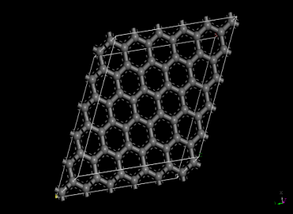

Fig. S15 Theoretical calculated band structure of graphene



Fig. S16. Absorption spectra of TiO2, TiO2-Pd, Graphene, TiO2/Graphene and TiO2-Pd/Graphene



Fig. S17. Absorption spectra of TiO2-PdX% and TiO2-Pd/Graphene Y%.



Fig.S18.XPS valence band spectra of TiO2, TiO2-Pd, Graphene, and TiO2-Pd/Graphene.



Fig. S19. Raman spectra of TiO2-Pd and TiO2-Pd/graphene at different temperatures.



Fig. S20. Cyclic voltammetry of TiO2 and TiO2-Pd.



Fig. S21. Verification of ROS generation ability for all samples.



Fig. S22. Verification of ROS generation ability for TiO2-Pd at different temperatures.

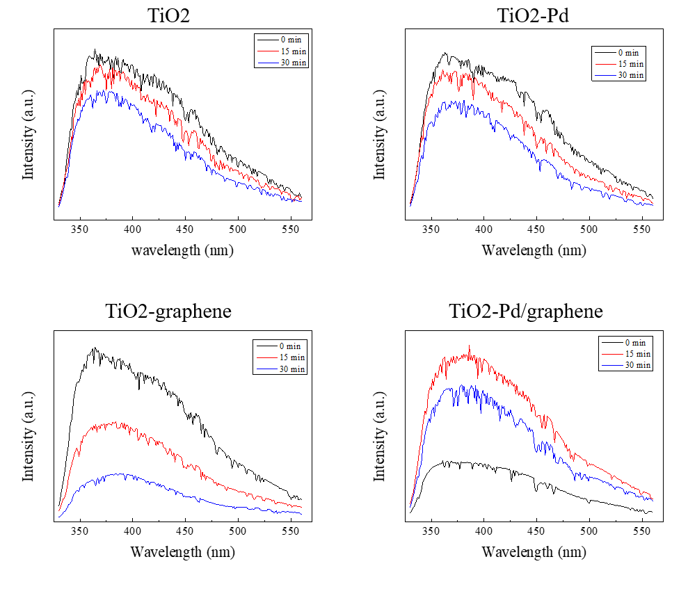

Fig.S23. PL spectral changes during irradiation in 0.5mmol/L terephthalic acid and 2mmol/L NaOH solution with all sample at 65oC for 0 min, 15 min and 30 min.

The generation of hydroxyl radicals was measured as follow: 5 mg of samples were added in 40 ml of mixed solution of 5% serum, 0.5mmol/L terephthalic acid and 2 mmol/L NaOH. After thermal treatment for 0 min, 15min and 30 min, 3 mL of supernatant was taken for measuring the PL intensity. The PL spectra were measured by the same instrument using the 315 nm line as the excitation source. It is noted that only TiO2-Pd/graphene samples can generate hydroxyl radicals at 65 oC. This suggest the strong ability of generating hydroxyls radicals for TiO2-Pd/graphene.